DATA FAMILIARIZATION
- The DePaul University applicant dataset contains 7,543 rows and 80 columns, with no duplicate rows.
- Data spans from May 2023 to June 2025.
- The dataset captures student demographics, academic program preferences, application processing details and outreach campaign activities.
- Columns include 30 text fields, 4 integer fields and 46 float fields, although a significant number of float columns contain no data (null).
- Initial impressions suggest the dataset is well-structured for analysing application trends by country, program and college, but will require data cleaning before deeper analysis.
DATA DICTIONARY: Data Dictionary

DATA QUALITY REPORT
The dataset contains 7,543 records and 80 columns. While no duplicate rows were found, the dataset has significant data quality issues across three categories: missing values, structural problems, and anomalies.
1. Missing Values Summary
- 38 columns fully empty
- 32 columns partially missing
- 10 columns fully complete
- Key missing value concern: Admit_Date (23.3% missing), outreach data (42.3% missing)
2. Duplicate Records
- 0 exact duplicate rows
3. Inconsistencies
- Country names inconsistently capitalised (e.g. "United states", "India")
- Application_Source uses mixed formatting ("STUDY GROUP" vs "Non Study Group")
- Phone numbers stored in multiple formats including scientific notation
- College names split between on-campus and online versions
- Outcome_1 contains similar labels with different labels.
4. Anomalies
Anomalies | Affected Columns | Recommendations
Spelling errors in column names | Recieved_At, Counsler | Rename to Received_At and Counselor
Unix timestamp format (unreadable dates) | Recieved_At, Created_At, Modified_At and 4 Duplicates | Convert to readable date format
Phone numbers are in scientific notation | Phone_Number | Flag affected rows
Multiple values packed into one cell | College, Intake | Split into separate columns during cleaning
Columns with only one unique value | University-2, University-3, Degree_Type, Type | Consider removing, no analytical value
Duplicate columns | 12 Columns ending in -2 or -3 | Review and drop true duplicates

EXPLORATORY DATA ANALYSIS
Descriptive Statistics
Column | Count | Average | Median | Min | Max | StdDev
Attempts | 4,349 | 1.00 | 1.00 | 1 | 1 | 0.00
Campaign_Id | 4,349 | 533,005 | 558,993 | 28,723 | 825,930 | 181,332
Reference_ID | 7,543 | 473,190,806 | 469,224,547 | 291,925 | 999,518,802 | 298,421,894
To Note: Not every numerical column gives you meaningful statistics. Reference_ID and Campaign_Id are identifier columns, they are numbers but they don't represent quantities you can meaningfully average or compare.
Frequency Count for Categorical Columns
Top 10 Countries
Country | Count
India | 4617
United States | 764
Ghana | 440
Nigeria | 430
Pakistan | 273
China | 125
Nepal | 81
Iran | 75
Canada | 69
Kenya | 62
Top 5 Colleges 1st Choice
College | Count
Jarvis College of Computing & Digital Media | 3,831
Kellstadt Graduate School of Business | 2,523
College of Science and Health | 269
College of Education | 208
College of Liberal Arts & Social Sciences | 207
Top 10 Programs Applied For
Programs | Count
Business Analytics - MS | 1,080
Computer Science - MS | 1,055
Data Science - MS | 519
Cybersecurity - MS | 423
Health Informatics - MS | 413
Information Systems - MS | 331
Artificial Intelligence - MS | 312
Finance - MS | 296
Human-Computer Interaction - MS | 270
Business Analytics (MBA) | 200
Application Source
Source | Count
Non Study Group | 6,528 (86.5%)
STUDY GROUP | 1,015 (13.5%)
Admissions by Year
Year | Count
2023 | 1,377
2024 | 3,805
2025 | 607

DATA VISUALIZATIONS
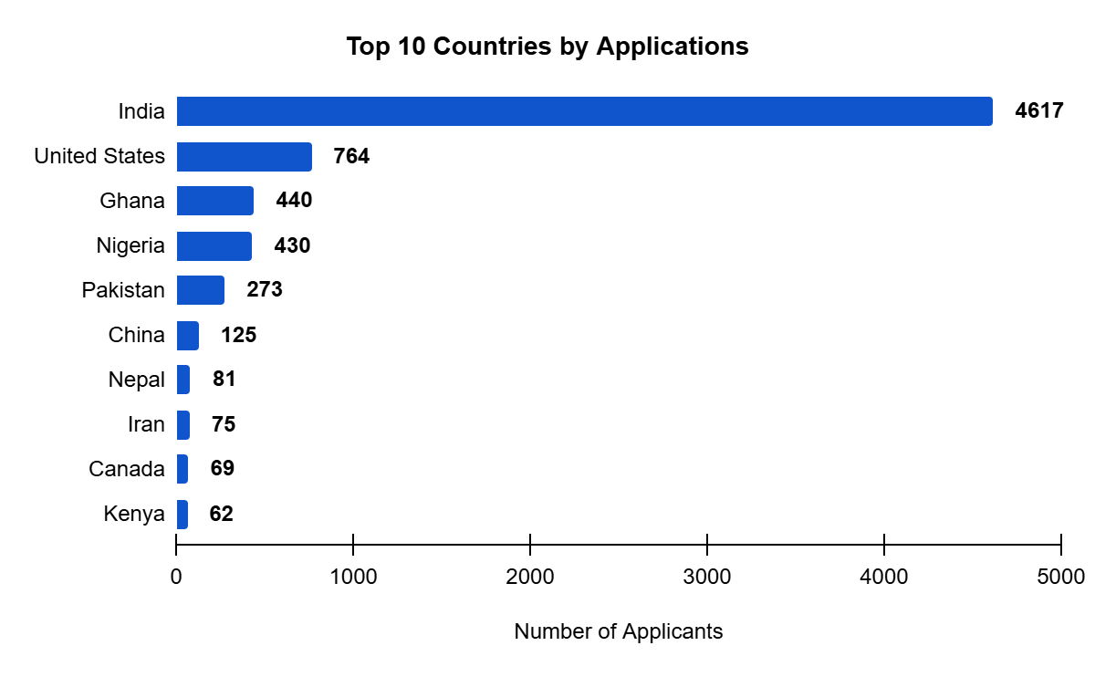
India dominates with 4,617 applicants, more than 6 times the second highest country, the United States at 764. The top 4 countries are India, USA, Ghana, and Nigeria account for nearly 80% of all applications.
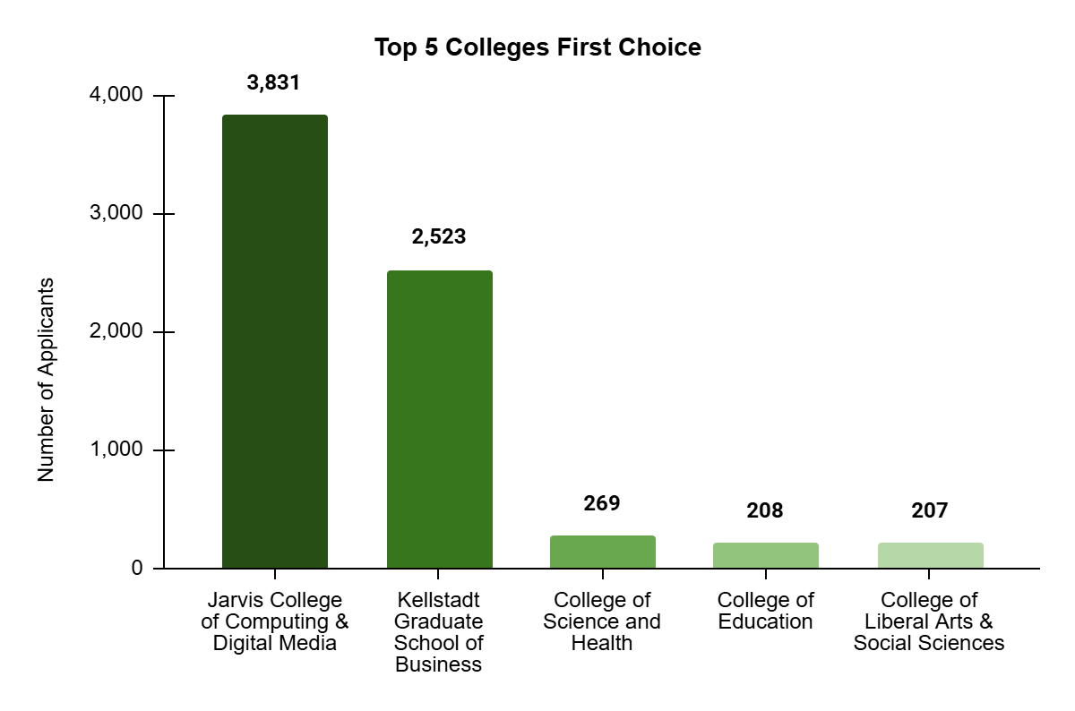
Jarvis College of Computing and Digital Media - 3,831 and Kellstadt Graduate School of Business - 2,523 together account for 84% of all college preferences.

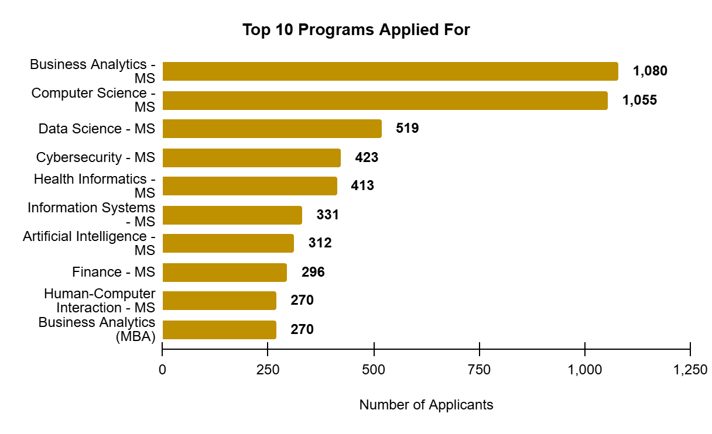

Business Analytics MS - 1,080 and Computer Science MS - 1,055 are nearly tied as the most applied for programs. Data Science, Cybersecurity and Health Informatics follow.
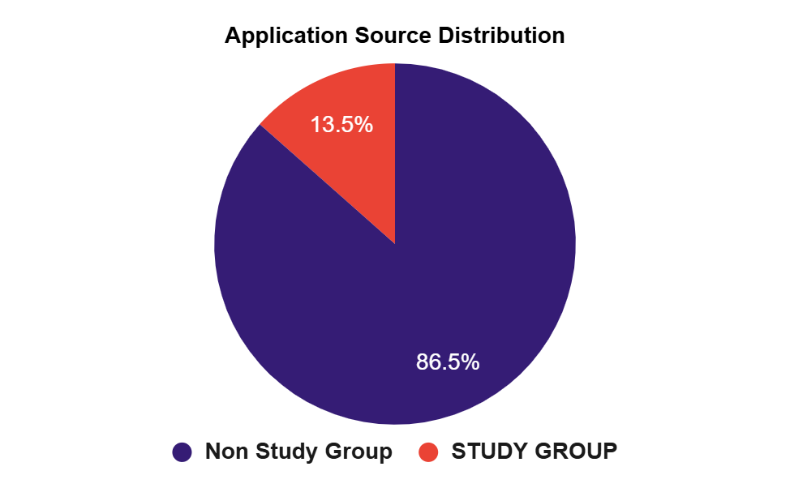
86.5% of applicants came through Non Study Group channels, while only 13.5% came through Study Group.
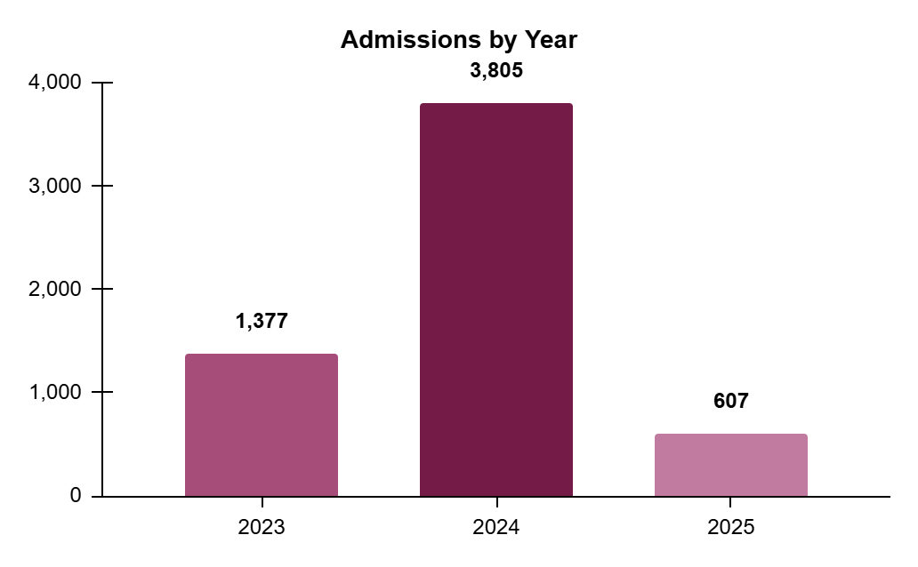
Admissions grew from 1,377 in 2023 to 3,805 in 2024, a 176% increase. 2025 shows 607, but this is a partial year.
INSIGHTS SUMMARY
Finding 1 - India accounts for 4,617 out of 7,543 applicants, 61.2% of the entire dataset. The next four countries - USA, Ghana, Nigeria, Pakistan together make up only 25.6%.
INSIGHT - If student interest or visa policies in India change, DePaul's application numbers would be significantly impacted.
Finding 2 - The top 3 programs: Business Analytics MS (1,080), Computer Science MS (1,055) and Data Science MS (519) together account for 35.3% of all applications. Seven of the top 10 programs are technology or data-focused.
INSIGHT - Demand for tech programs is the primary reason for applications. DePaul's Jarvis College of Computing, which received 50.8% of all first-choice selections, is clearly the most attractive college to applicants.
Finding 3 - Admitted students jumped from 1,377 in 2023 to 3,805 in 2024.
INSIGHT - This is a remarkable growth rate. It could reflect a successful recruitment push, expanded program offerings, or increased international interest. Understand what drove this increase for Week 2 analysis.
Notable Trends and Patterns
- Jarvis and Kellstadt colleges attract 84.2% of all applicants while all other colleges share the remaining 15.8%, indicating highly concentrated demand.
- Study Group applicants are made up of India (65%) and the USA (18%), while Ghana and Nigeria apply almost entirely through Non Study Group channels.
- Indian applicants' top programs mirror the overall dataset exactly, which is expected given their 61.2% share, but confirms that overall application trends are largely shaped by Indian student preferences.
Initial Observations for Week 2
- Is_Admitted is 100% empty, admission outcomes unknown.
Proposed action: Explore whether status can be inferred from Admit_Date or related columns.
- 176.3% admissions growth in 2024 is unexplained.
Proposed action: Time-series analysis by program and country to identify the driver.
- 3,194 applicants were never contacted.
Proposed action: Profile uncontacted students by country, program and year.
- The College column combines three values in one cell.
Proposed action: Split into country, university and degree type during cleaning.
- Timestamps are unreadable in three columns.
Proposed action: Convert to readable date format as the first data cleaning step.
- 38 fully empty columns and 5 zero-variance columns.
Proposed action: Drop all during Week 2 cleaning to reduce the dataset to quality columns.

